Kingston FURY Renegade PCIe 4.0 NVMe M.2 SSD

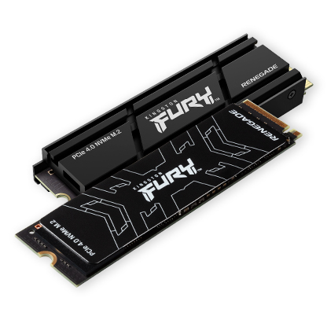

**Key Features:**

* **Unmatched Speed**: Sequential read/write speeds of up to **7,300/7,000 MB/s**, ensuring fast load times and improved multitasking.
* **Capacities**: Available in 500GB, 1TB, 2TB, and 4TB, offering flexible storage solutions for games, media, and applications.
* **Optimized for PCIe 4.0**: Delivers twice the performance of PCIe 3.0 SSDs, making it future-proof and ideal for high-end setups.

**Compatibility:**

* Works seamlessly with PS5 consoles (requires system software version 21.02-04.00.00 or later).
* Compatible with desktops and laptops that support M.2 2280 form factor and PCIe 4.0 slot

**Ideal For:**

* High-performance gaming setups.
* Video editing, rendering, and other data-intensive tasks.
* Building custom PCs that prioritize speed and efficiency.

Warranty:

* Coverage against defects in materials and workmanship.